***Data Analytics***

**Case Study: Classification of term deposit buyers for retail banking**

1. **Data Refinary**

* Descriptive analytics of data

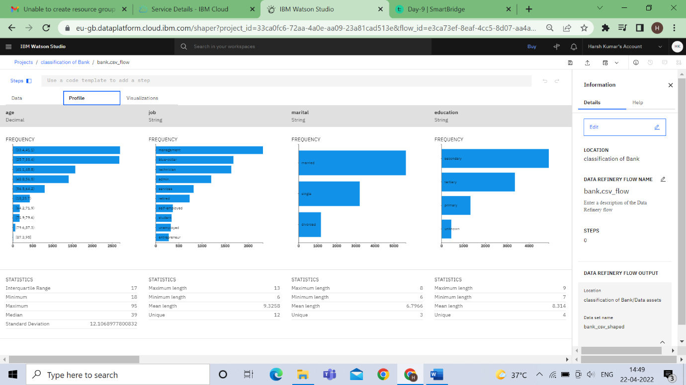

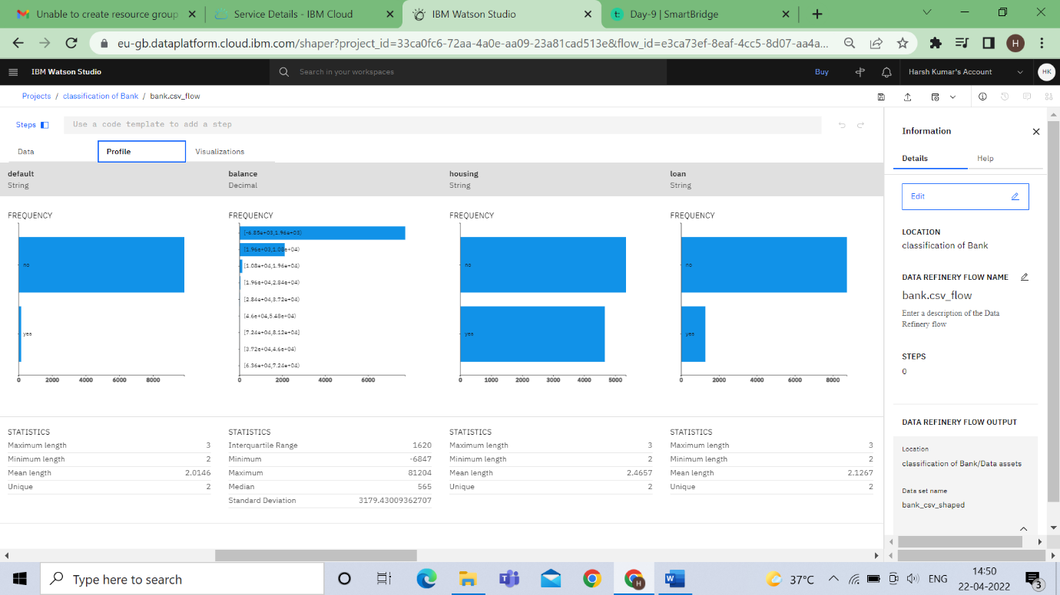

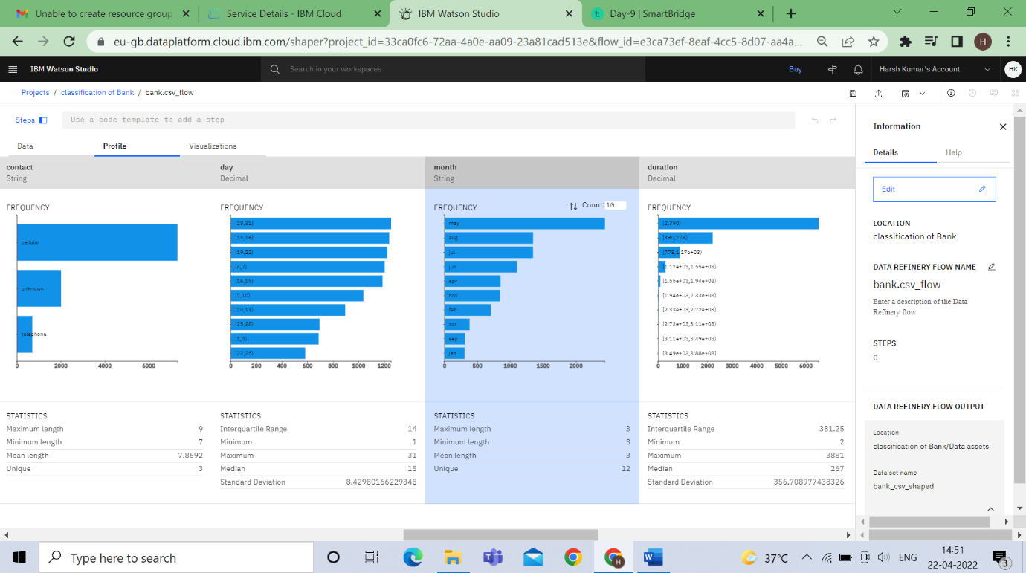

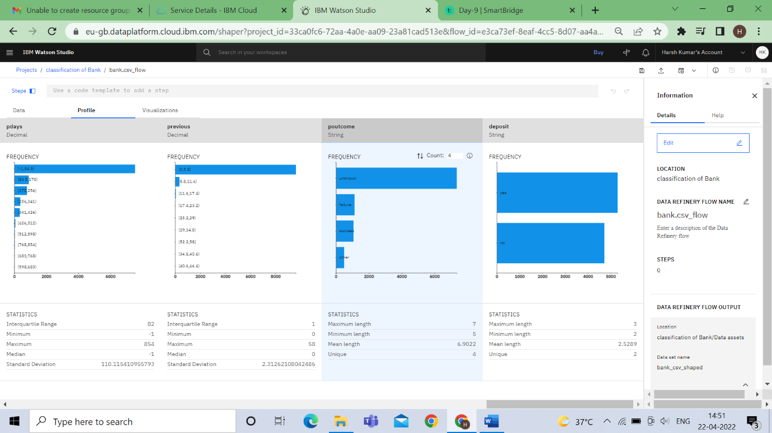

* Exploratory Analytics

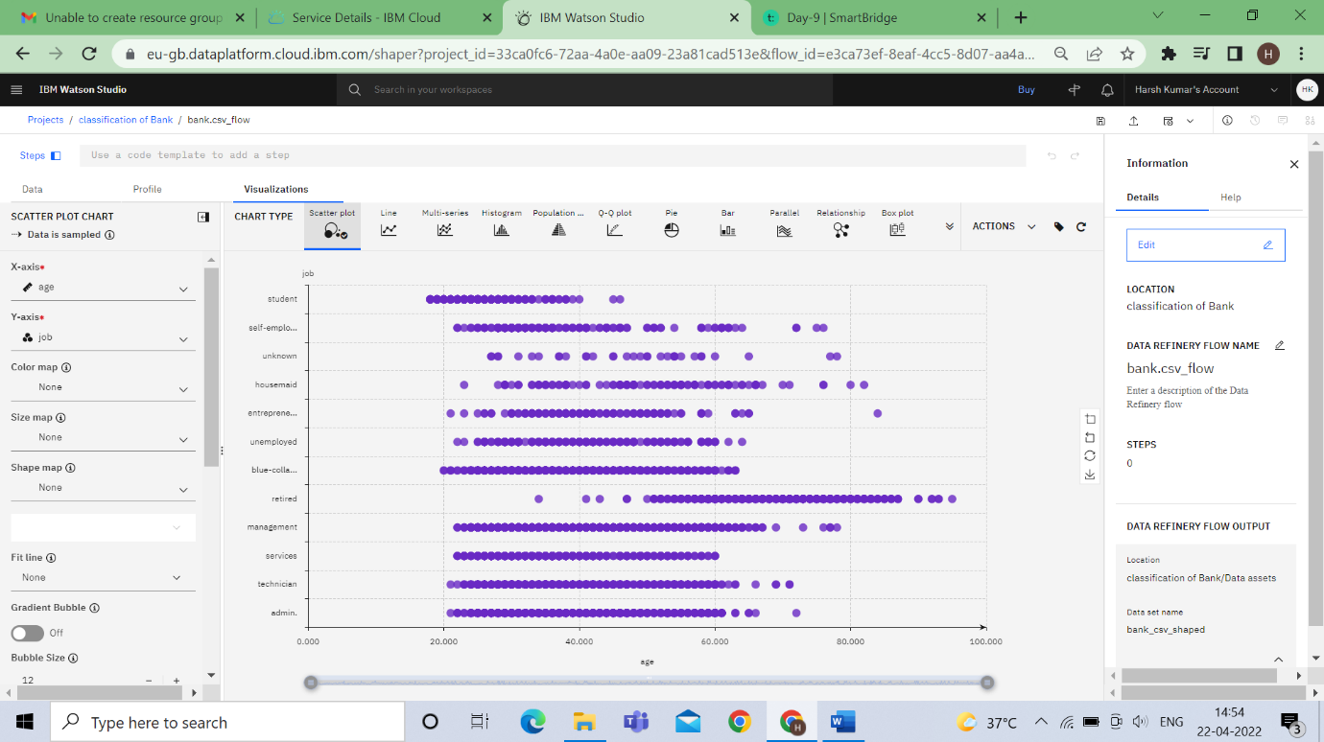

x-axis = Age ,y-axis=Job

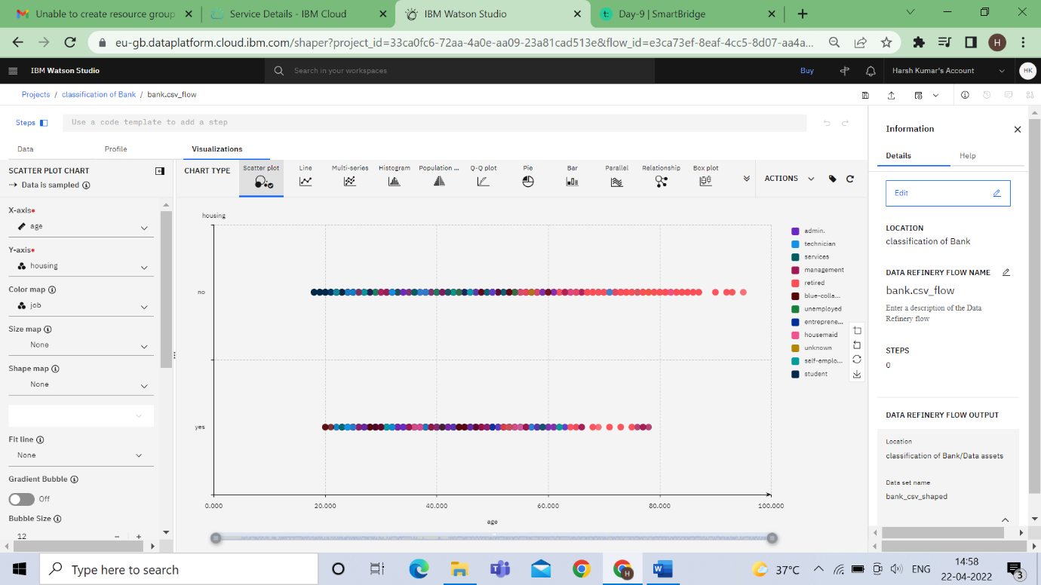

x-axis=Age ,y-axis= housing.color-job

**2.SPSS Modeler**

* **Model**

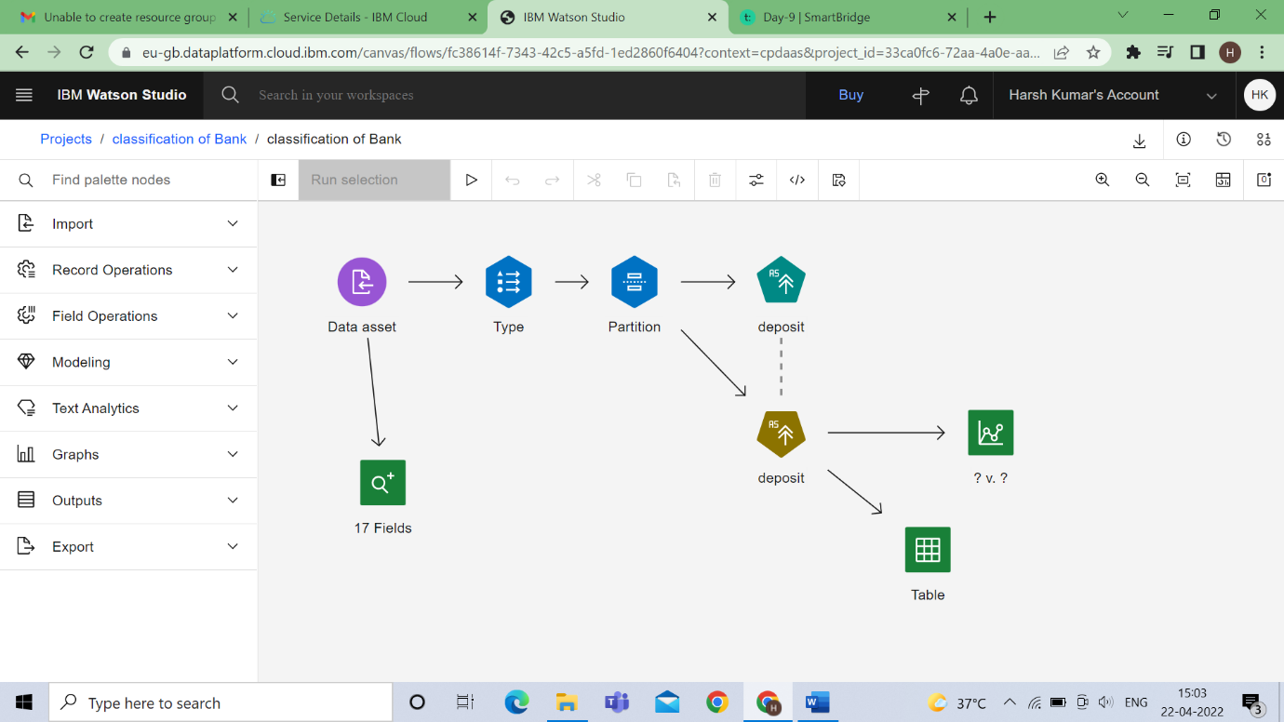

* **Type node**

**age as Input**

**marital as input**

**balance as input**

**deposit as Output or terget**

**Other as none**

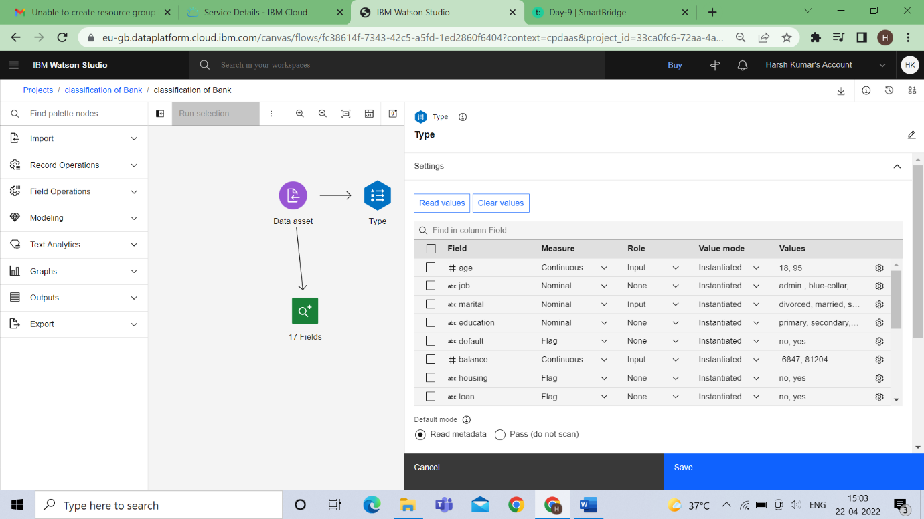

* **Partition node**

**Training – 70%**

**Testing – 30%**

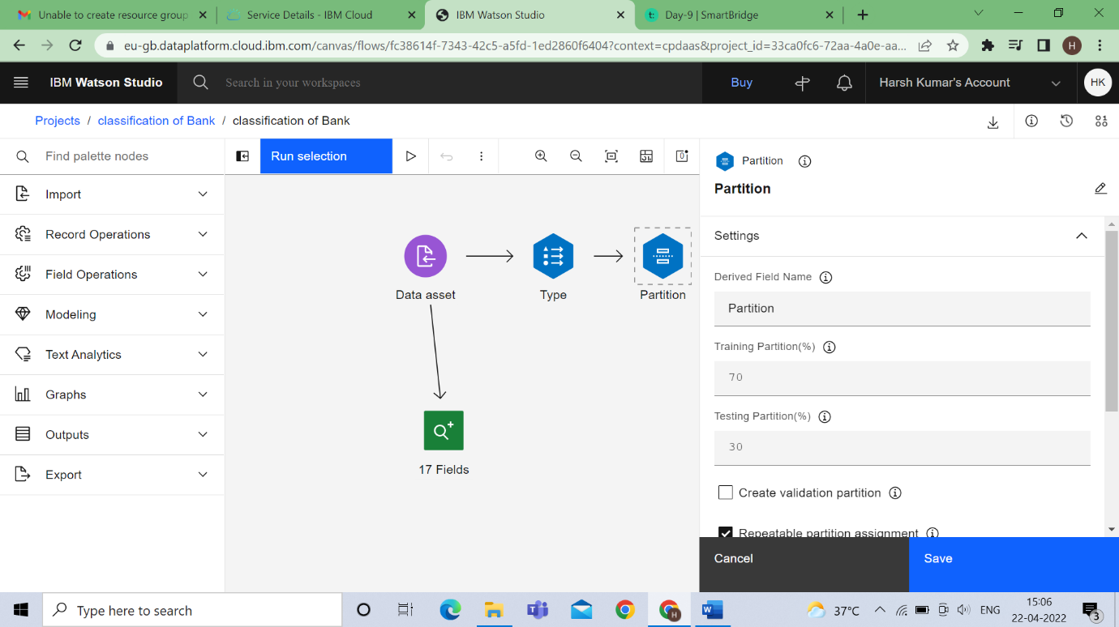

* **Model**



* **Output**

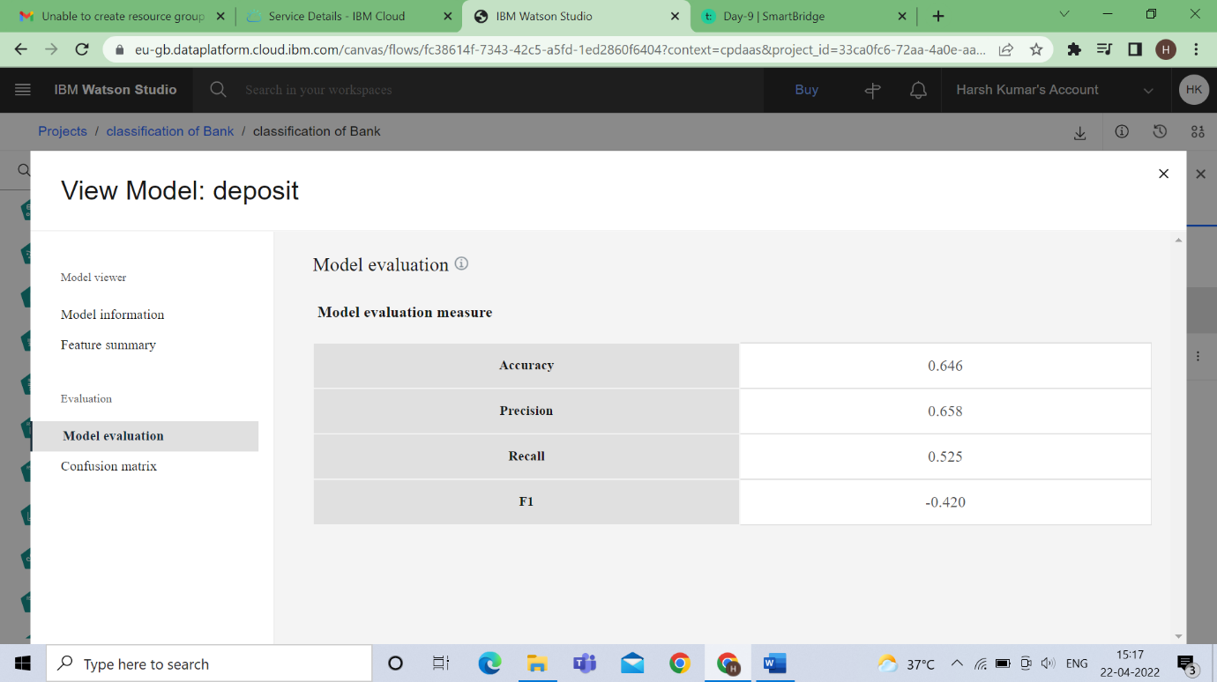

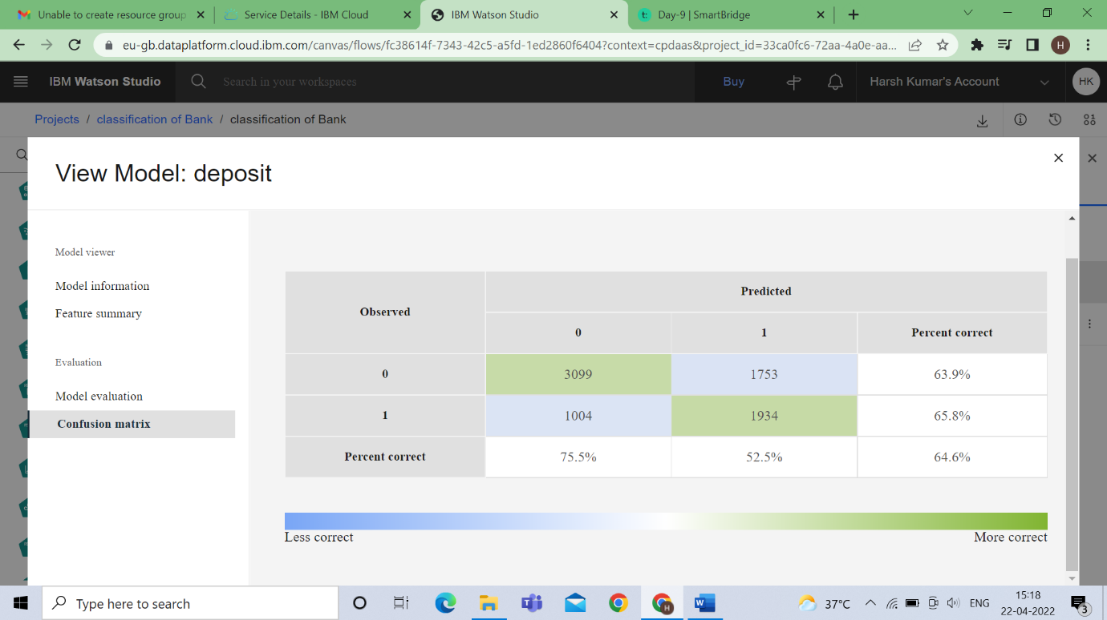

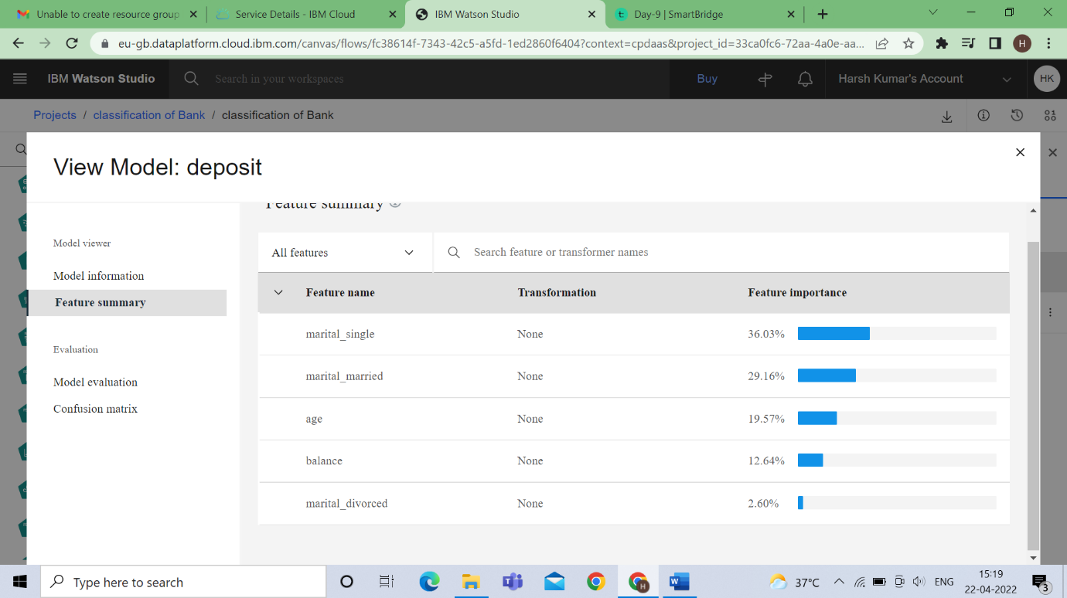

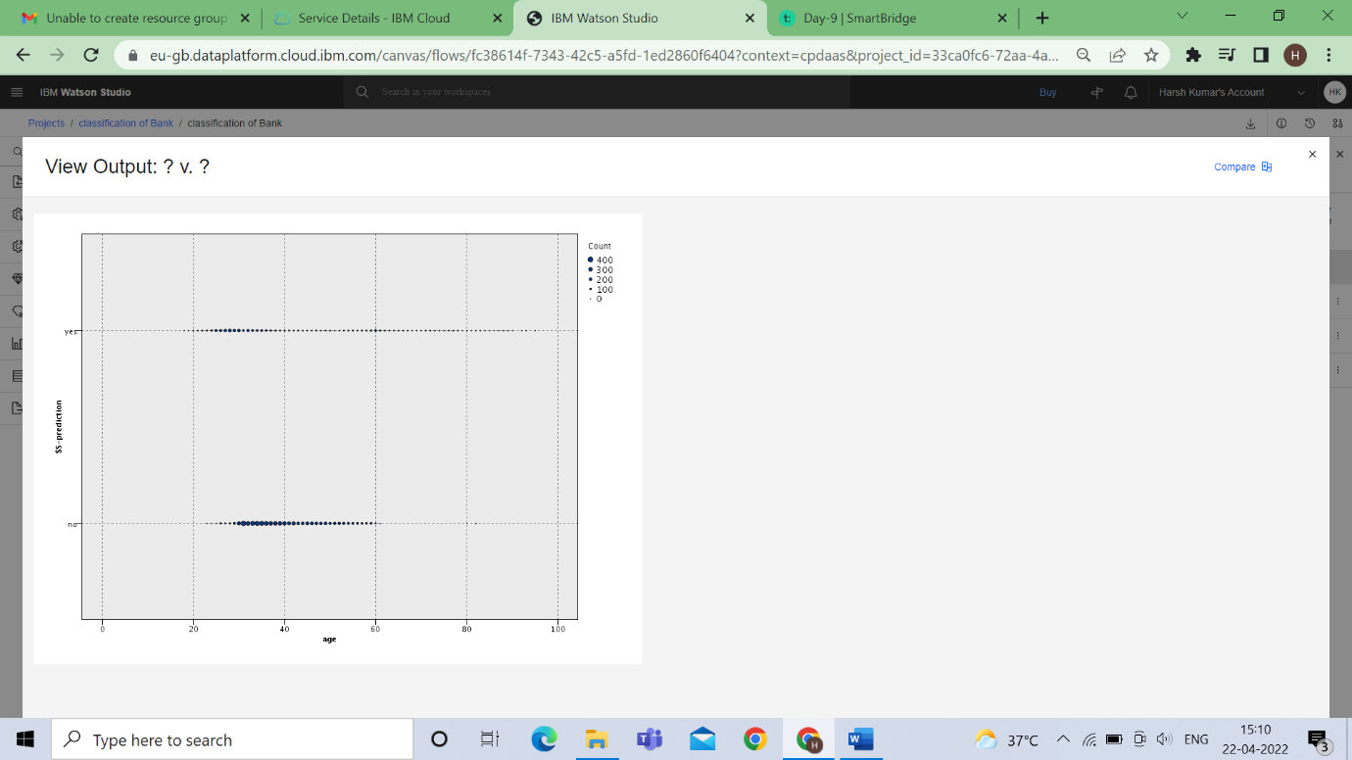

**x-axis = age,y-axis-$XGTdeposit**

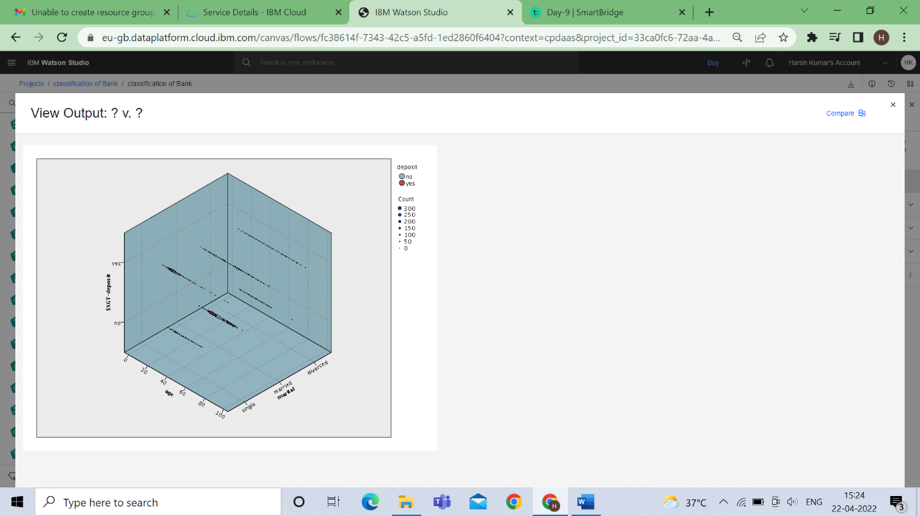

**x-axis = age ,y-axis=$XGTdeposit ,z-axis=marital, color=deposit**

* + **Data Audit**

